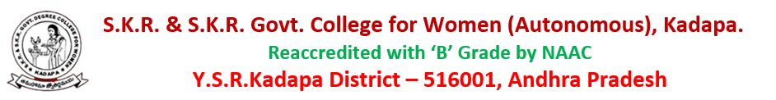
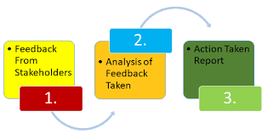
1.4.1 - Structured feedback and review of the syllabus (semester-wise / year-wise) is obtained from 1) Students 2) Teachers 3) Employers and 4) Alumni
The college collects feedback on curricular aspects from various stakeholders namely:
1) Students
2) Teachers
3) Employers
4) Alumni

SKR & SKR Govt. College for Women (A), Kadapa has structured feedback mechanism in reviewing the syllabus from time to time. The college has collected the feedback on the curriculum from the stakeholders – students, teachers, alumina and employers
to have responses from the stakeholders regarding the relevance, utility, feasibility and applicability of the system in the current academic scenario. This helps us to improvise our curriculum as per the expectations of the stakeholders. In the Academic council/BOS meetings bridged the gaps and made necessary changes to increase the standards of the curriculum in various courses if necessary. Introduction of new courses to meet the current needs of the global competence to strengthen the students to face global challenges and also to pursue higher education. Stakeholder wise feedback analysis and action taken report is given below:

Feedback Analysis of Stakeholders And Action Taken Report
The institution considers the curriculum as the heart of education and finds it important to assess the feed back from its stakeholders-Students, Teachers, Employers and Alumni. After receiving the feed back in the structured format, the IQAC analyses, identifies gaps and made
Suggestions to the departments for implementation. Feed back forms prepared in Google and circulated through Whatsapp Groups of stakeholders.

Students Feedback on Curriculum:
The feedback on curriculum from students were obtained after the end of each academic session. Students opinion on syllabus were measured in a four-point scale
1. Excellent 2.Very Good 3. Good 4. Satisfactory.
For analysis, 238 students from 18 UG programs and 2 PG programs provided feedback on the curriculum. The data collected has been analysed and the results given below:
Student feedback on Curriculum-UG 2021-22
Curriculum Feedback Analysis Report
Students’ feedback

Table 1: Students feedback and action taken report based on the student’s feedback on curriculum, appropriate changes were made in syllabus, shown in Table 1.

Table 1: Percentage distribution of responses by categories
1 | The Syllabus is suitable to the programme, need based and updated
2 | They syllabus has good balance between theory and application
3 | The syllabus generates interest in the subject area
4 | The syllabus is relevant to professional development and preparation for job
5 | The syllabus covers recent trends and developments
6 | The syllabus prepares and motivates to pursue higher education/research.

Curriculum Feedback Analysis Report
Questions | Q1 | Q2 | Q3 | Q4 | Q5 | Q6
Excellent | 59 % | 40 % | 47 % | 44 % | 51 % | 48 %
Very Good | 29 % | 43 % | 35 % | 41 % | 13 % | 1 %
Good | 11 % | 16 % | 17 % | 33 % | 15 % | -
Satisfactory | - | 1 % | 2 % | 38 % | 12 % | 8 %

The feedback collected from students is depicted in pie diagram for each question:

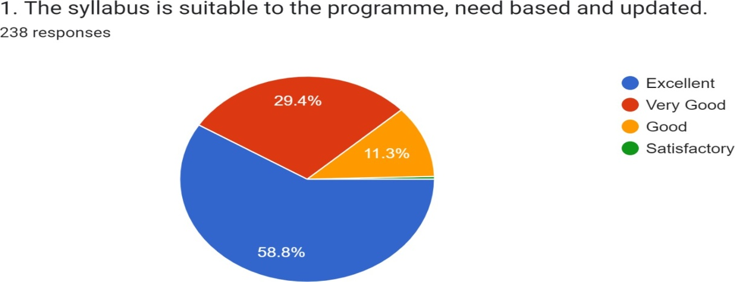

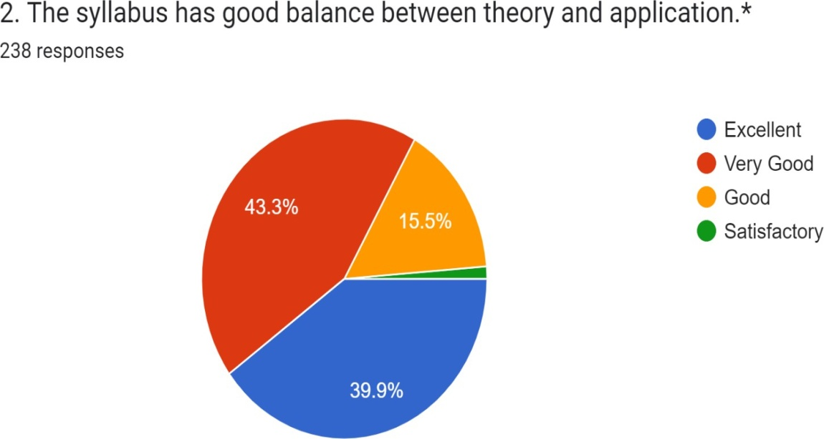
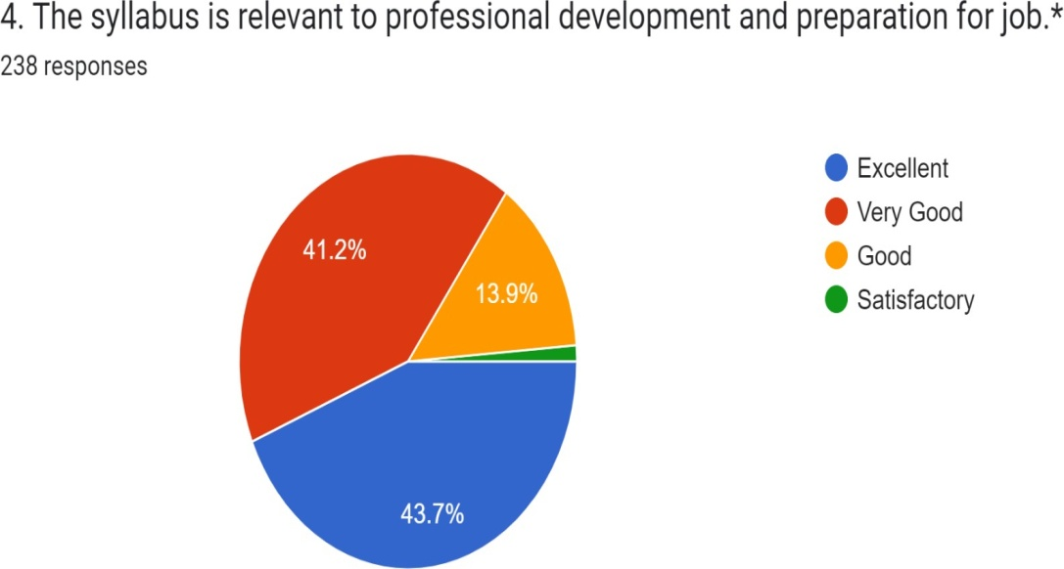
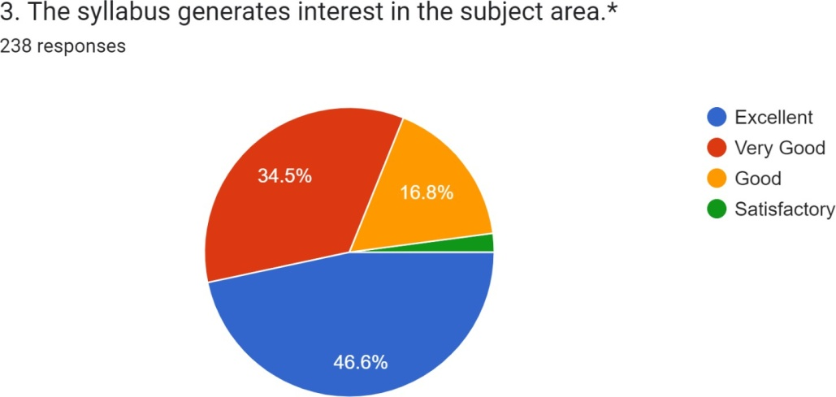
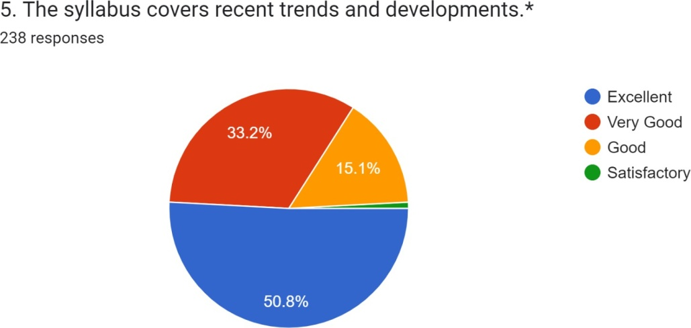
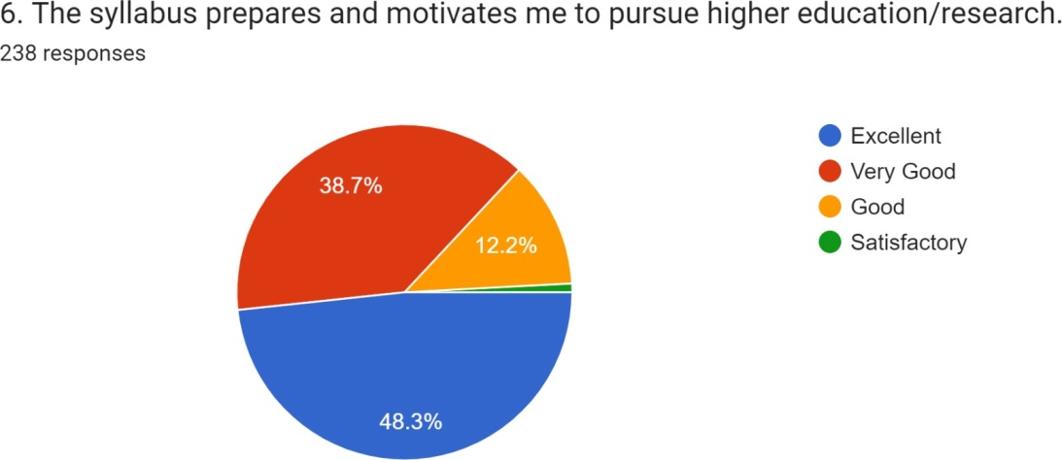

ACTION TAKEN REPORT ON
STUDENT’S FEEDBACK ON CURRICULUM

The BOS members have decided unanimously that additional/alteration of syllabus must be carried out in regular intervals based on the feedback to meet the needs of the society.

- New UG Programme BA (HPU) started in the year 2021-22 and BBA- Event Management Programme will be started from the year2022-2023.
- 17 Certificate Courses organized in various disciplines to enrich knowledge of the students.
- Field trips, Study projects, Community Service projects (CSP) were done.

II-Teacher’s Feedback Analysis Report 2021-2022
The feedback on curriculum from teachers were obtained after the end of each academic year
2021-22. Six curriculum-related questions was designed to the Teachers questionnaire. Teacher’s opinion on syllabus were measured in a four point scale
1. Excellent 2. Very Good 3. Good 4. Satisfactory. 44 Teachers from 19 UG programs and 2 PG programs have responded and provided feedback on the curriculum.

Table 2: Percentage distribution of responses by categories
Q.NO | Description
1 | The Syllabus is need based, updated and has good balance between theory and application
2 | They syllabus provides comprehensive knowledge and perspective in the subject area
3 | The assessment and evaluation system objectively measure the course outcomes (Cos)and Program Specific Outcomes (PSOS)
4 | The college has enough relevant resources which are updated regularly for teaching learning purposes
5 | Course content has enough scope for development of analytical, logical, technical and creative skills to the students
6 | The syllabus has prospects for competitive exams/higher education/employability

Feed Back Analysis Report in the form of Percentages
Questions | Q1 | Q2 | Q3 | Q4 | Q5 | Q6
Excellent | 88 % | 77 % | 70 % | 68 % | 72 % | 68 %
Very Good | 11 % | 22 % | 29 % | 29 % | 27 % | 31 %
Good | -- | -- | -- | 3 % | -- | --
Satisfactory | -- | -- | -- | -- | -- | --

Teachers’ Feedback on Curriculum is shown in the form of Pie diagram:

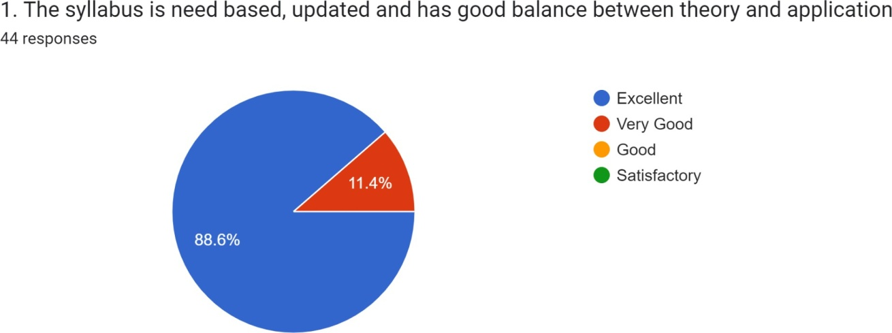

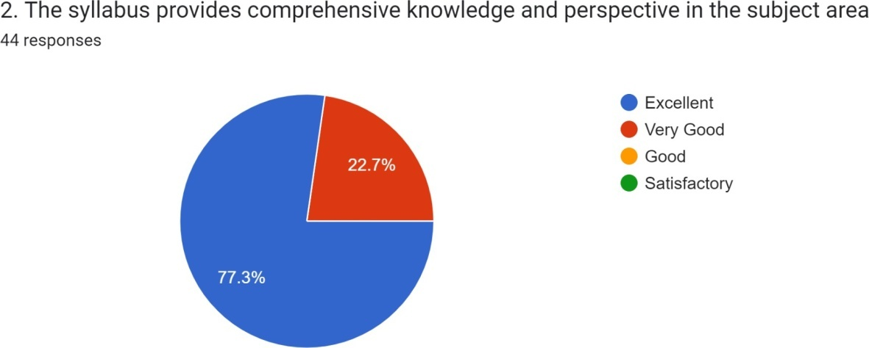

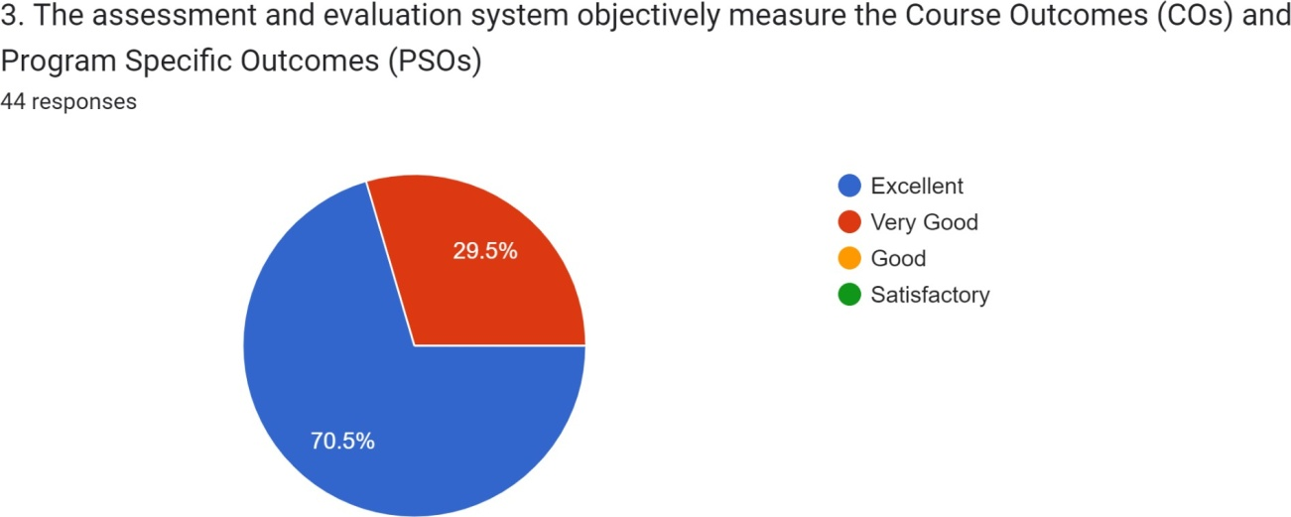

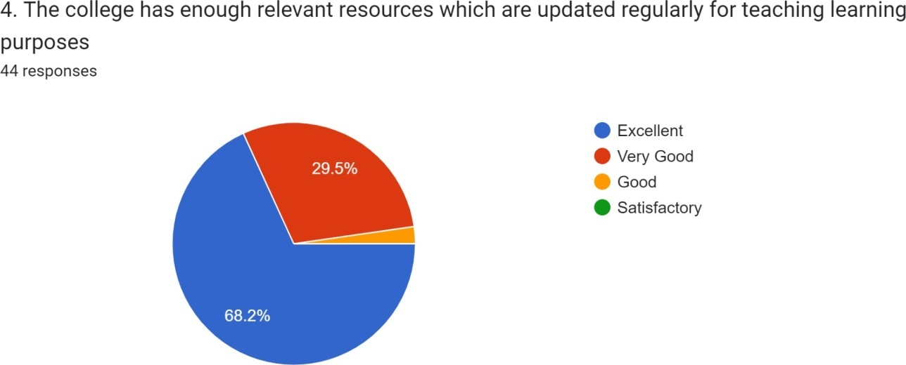

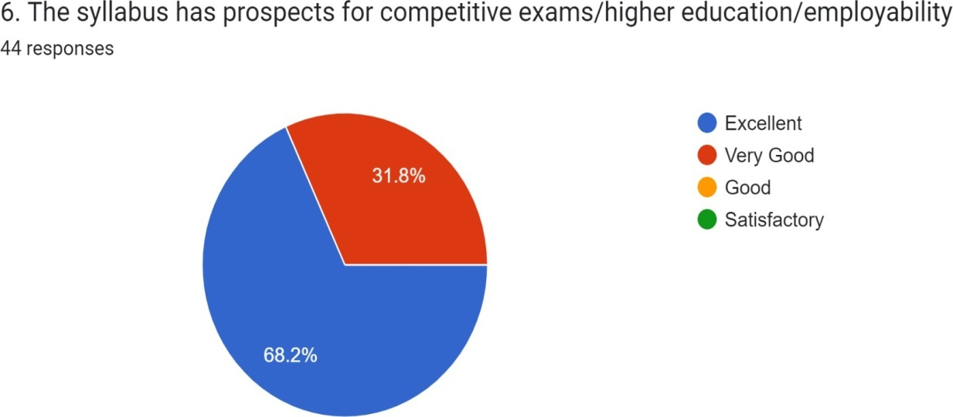
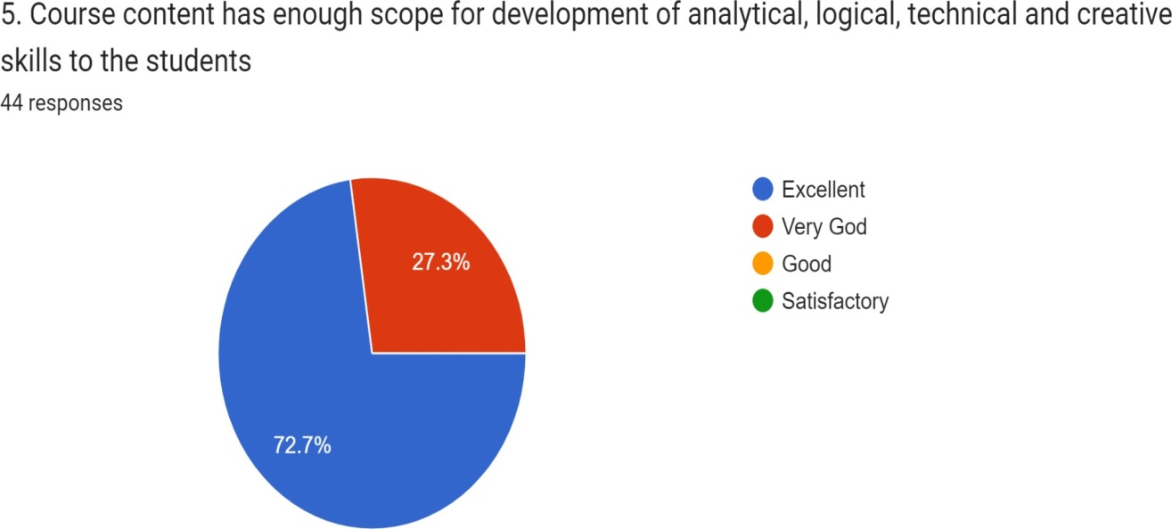

Action Taken Report On
Teachers Feedback on Curriculum

The majority of teachers had very positive thoughts about how curriculum development is carried out, according to feedback analysis report results. The faculty has unanimously agreed that adding to or changing the syllabus must be done periodically. Department of English 5% syllabus was replaced and paper IV & V added in the syllabus. Department of Economics 20% syllabus was replaced. Department of Political science 20% syllabus changed, Department of Computer Science 10% added in Semester IV, and 1% syllabus removed, Department of Statistics 10% syllabus was replaced, Department of Biochemistry 10% syllabus is replaced, Department of Chemistry replaced 20%, Department of Physics 15% changed, Department of Mathematics changed 10% of the syllabus.
New UG Programmes BA (HPU) started in 2021-22 and BBA will be started in 2022-2023.
2. 17 Certificate Courses was organized
3. Field trips, study projects, Community Service projects (CSP) was done
4. Coaching for Post-Graduation entrance Examinations was providing for out going
students.

Alumni Feedback Analysis Report

The feedback on curriculum from Alumni were obtained after the end of each academic year2021-22. Eight curriculum-related questions designed for Alumni questionnaire. Students opinion on syllabus were measured in a four -point scale
1- Excellent-2- Very Good -3-Good-4- Satisfactory. 42 Alumni was given feedback on the curriculum.
Feed Back Analysis Report
S.No | Description
1 | Syllabus was updated
2 | The Course content delivery was interesting
3 | The course curriculum was intellectually
4 | Sufficient number of prescribed books is available in the Library
5 | The course curriculum was fulfilling expectations
6 | The syllabus created an interest in pursuing PG/Research studies
7 | The syllabus has helped in career.
8 | Specify the technologies/topics to be added to make syllabus/curriculum more updated.

Questions | Q1 | Q2 | Q3 | Q4 | Q5 | Q6 | Q7 | Q8
Excellent | 55 % | 41 % | 41 % | 50 % | 45 % | 43 % | 44 % | 33 %
Very Good | 36 % | 38 % | 29 % | 19% | 26 % | 43 % | 34 % | 36 %
Good | 10 % | 14 % | 29 % | 19% | 19 % | 9 % | 19 % | 26 %
Satisfactory |  | 7 % | 2 % | 12 % | 10 % | 6 % | 3 % | 5 %

Alumni Feedback Analysis Report-2021-2022
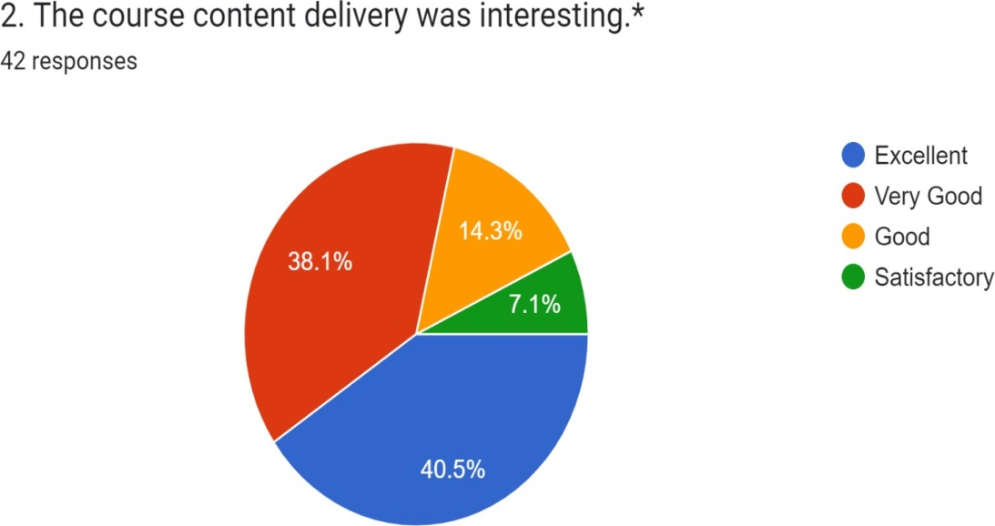
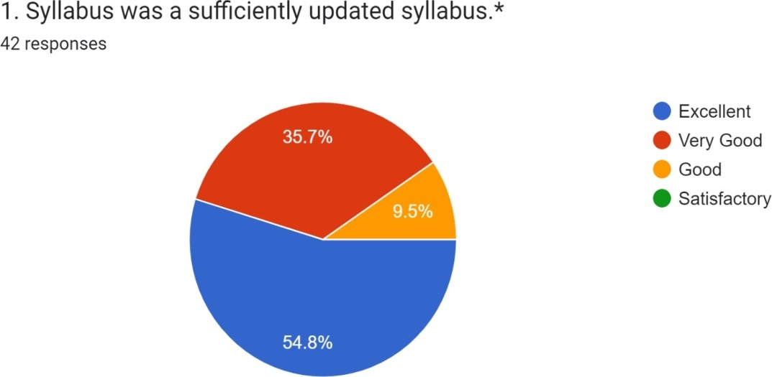

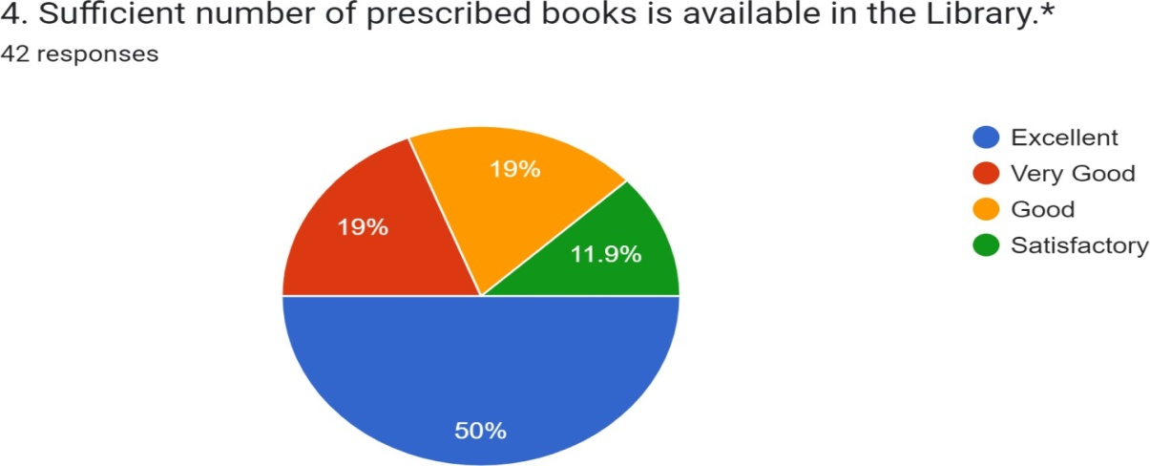
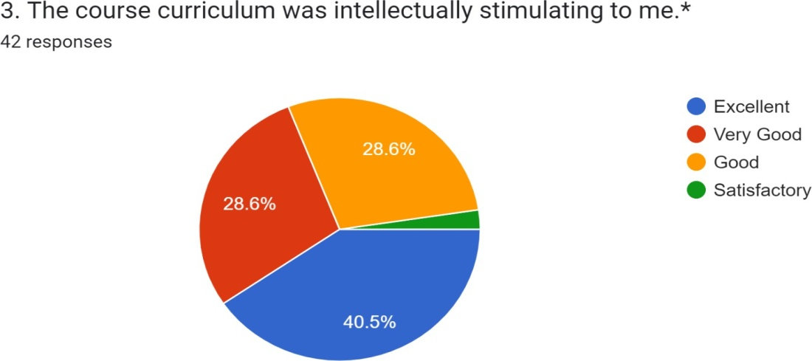

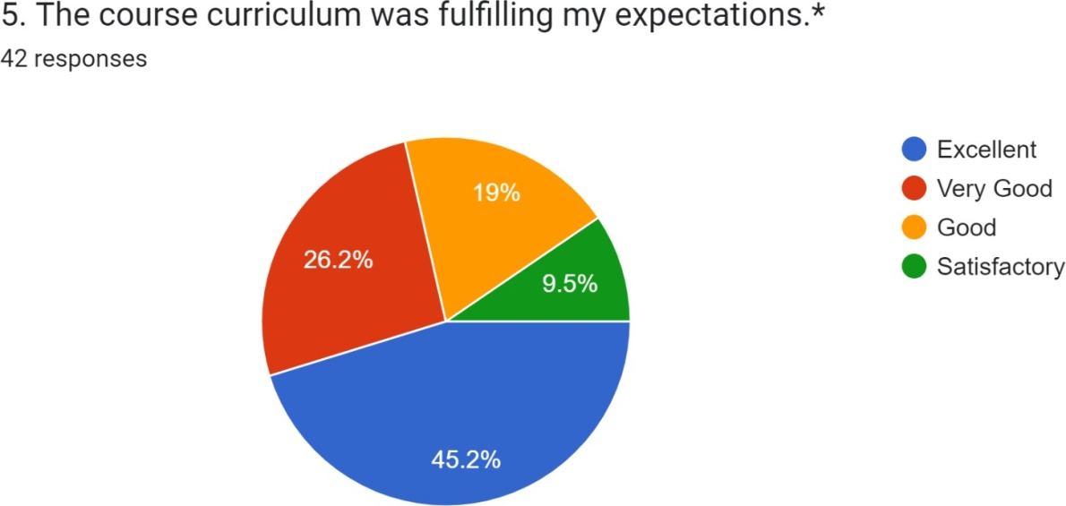

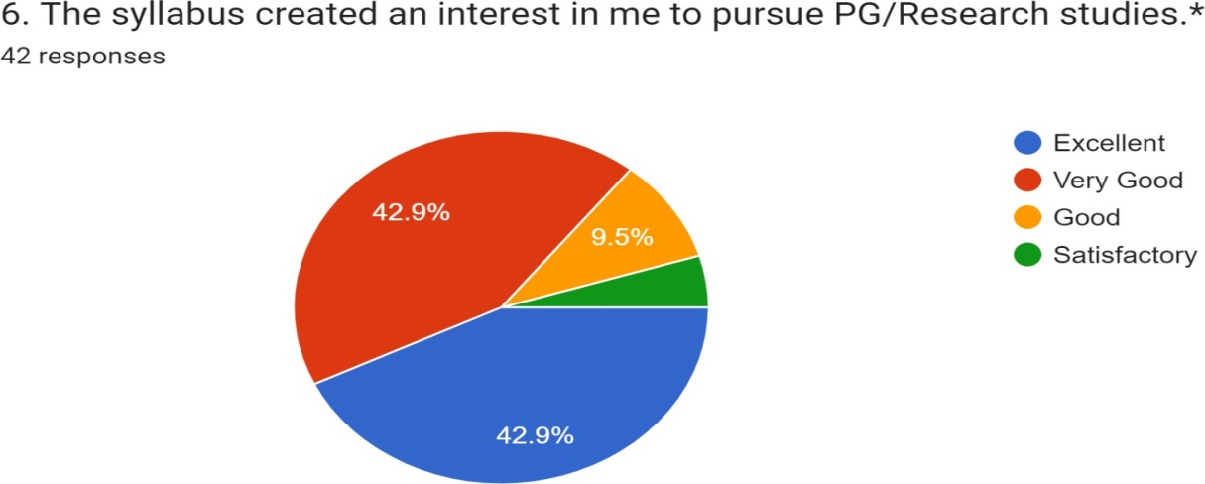

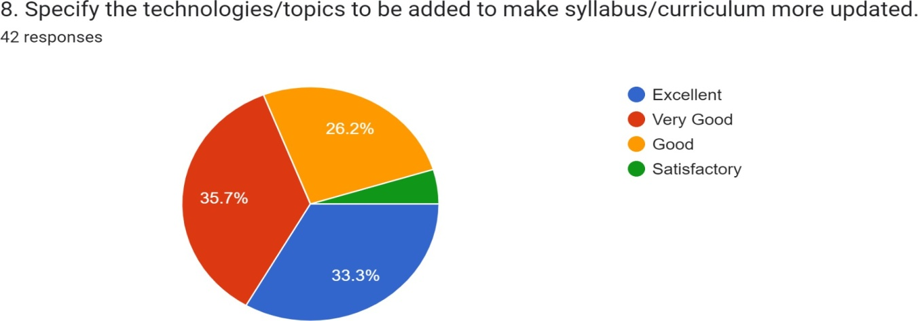
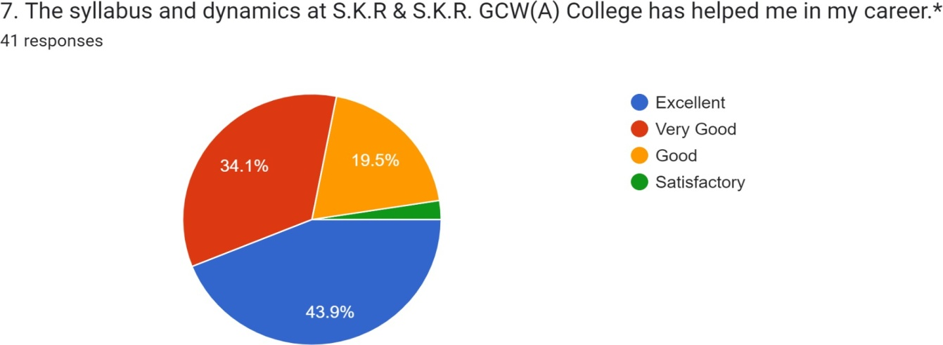

ACTION TAKEN REPORT
Most of the Alumni are of Excellent opinion on curriculum design and development. Very few expressed improvements over some questions. Based on these opinions the following action has been taken.
S.No | Areas on which students expressed dissatisfaction | Action Taken
1 | Ability to work in arduous /Challenging situation | These areas, on which Alumni expect improvement, have been considered and are conveyed during evaluation time to the BOS members.
2 | Resource and Time management skills
3 | Oral communication

Employer Feedback Analysis Report
Online analysis on the curriculum and associated topics have been gathered in IQAC. The feedback on curriculum from employer were obtained after the end of each academic
2021-22 session. six curriculum-related questions was designed for the questionnaire. Students opinion on syllabus were measured in a four -point scale
1- Excellent-2- Very Good -3-Good-4- Satisfactory. 19 Employers was provided feedback on the curriculum.
S.No | Description | Excellent | Very Good | Good | Satisfactory
1 | The syllabus makes the students competent | 57.9% | 42.1% | -- | --
2 | The syllabus promotes innovate | 57.9% | 42.1% | -- | --
3 | The syllabus effective to developing the entrepreneurial skills of the student | 57.9% | 42.1% | -- | --
4 | The syllabus enables to enchase the quality of the students in terms of presentations, aptitude, behavior, attitude, subject knowledge, technical and communication skills | 100% | -- | -- | --
5 | Course content has enough scope for development of analytical, logical technical and creative skills to the students | 73.7% | 26.3% | -- | --
6 | Awareness on the recent developments in the field is provided. | 42.1% | 47.4% | 10.5%

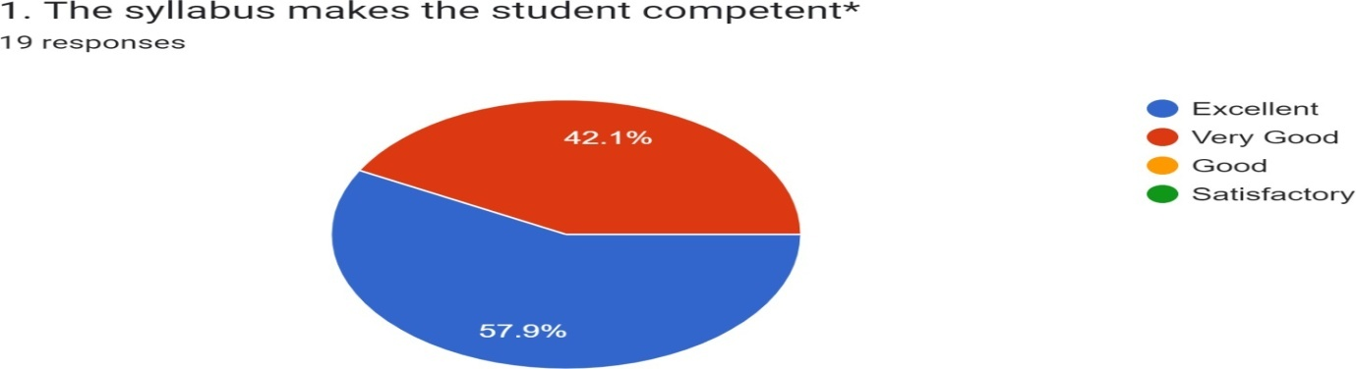
Employer feedback Analysis:

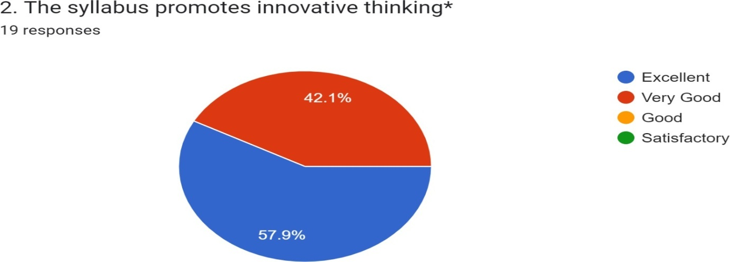

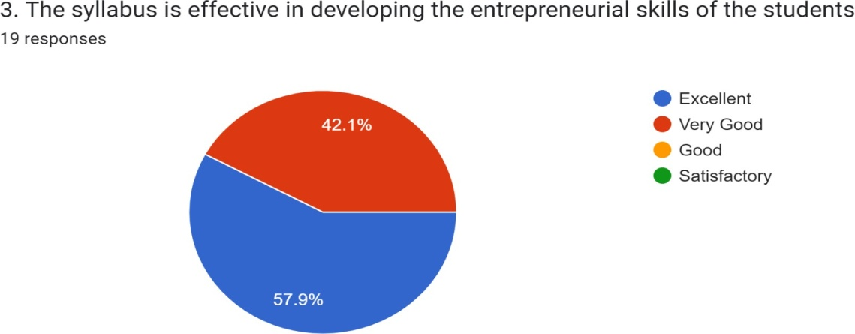

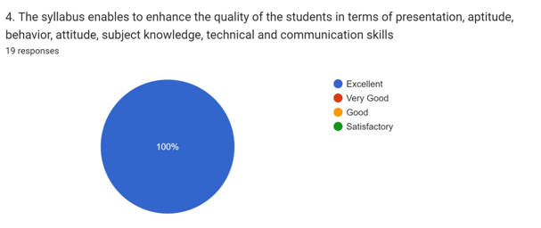
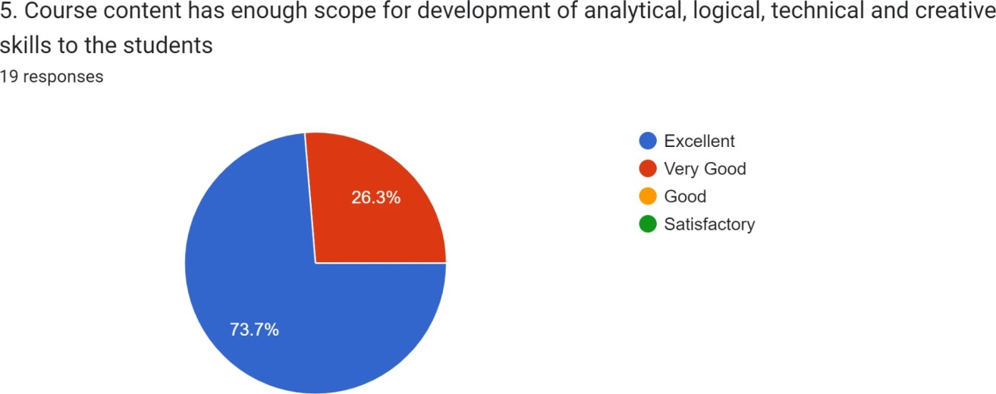

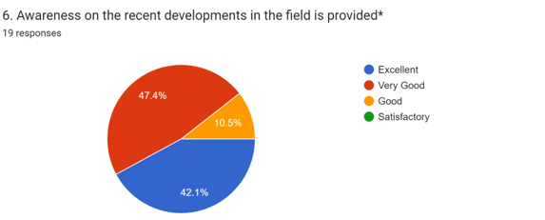

ACTION TAKEN REPORT
Employer’s Feedback on Curriculum

All Most all the employers are of Excellent opinion on curriculum design and development. . JKC, Placement cell of college is organising on campus and off campus job drives in order to provide job opportunities to the students. JKC is imparting batch wise training to the students in Communication skills, Soft skills, Analytical skills, Computer skills, Mock interviews, preparation of resumes, online submission of applications for jobs etc.

